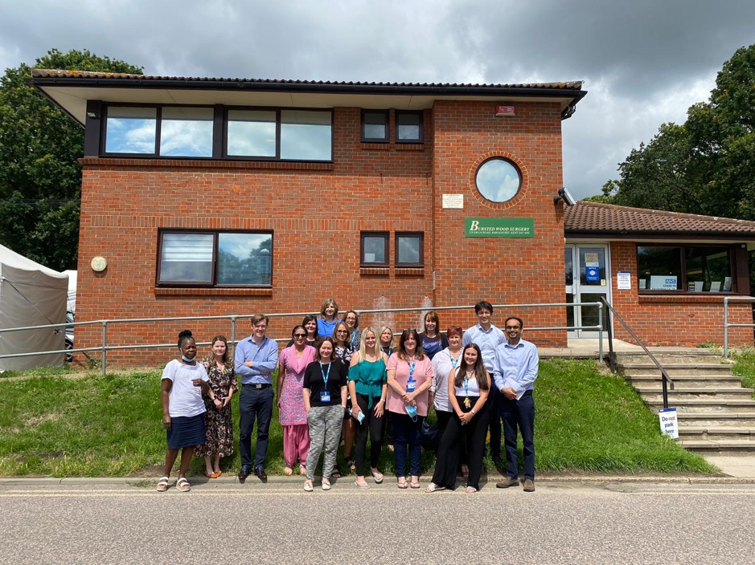
Meet the team at Bursted Wood Surgery

Nhs Health Checks

Patients aged over 75 are invited to book a health check with our HCA

Shingles Vaccinations
Shingles vaccination is available NOW if you are aged 70,71,72,73,78 and 79years old

PLEASE CALL THE SURGERY TO ARRANGE YOUR APPOINTMENT WITH THE HCA /NURSE

Learning Disability Patients

We are now booking the annual reviews for our learning disability patients with our nurse

FLU Vaccination

We are now booking FLU vaccinations for September 2021 for aged 65+ and over and at risk please call reception.

Meet one of our clinical pharmacist Mrs Patel

As a clinical pharmacist in a GP surgery I work as part of the general practice team to improve value and outcomes from medicines .This involves resolving day-to-day medicine issues, carrying out medication reviews for patients with ongoing health problems and improving patient safety, outcomes and value through person –centred approach.
In my role as a clinical pharmacist I help to manage long term conditions, advising those taking multiple medicines and delivering clinical advice about treatments. I will also assist with communication across a patients care pathway, manage medicines shortages by suggesting suitable alternatives where appropriate.
I work along side a team of three pharmacists ,the practice Manager and clinicians .Its a pleasure to be part of the Bursted Wood Team.

